i-team Data Exercise - Baseline Report

Deniece Williams

## Background

During the 2024 hurricane season, the residents of Hillsborough County, Florida were hit by multiple environmental disasters. Evaluating baseline data can help researchers measure the true impact and path to recovery that goes beyond the dollar values.

Hillsborough county’s topography varies from coastal cities to rural farmlands. Based on the source data provided the population of 1,461,722 persons live in 325 census tracts covering an area of approximately 989.9 square miles.

|  |
| --- |
| [Hillsborough County](https://data.news-leader.com/census/total-population/total-population-change/census-tract-13907-hillsborough-county-florida/140-12057013907/) |

Hillsborough County

## Methodology

* Graphs and calculations were done in R
* This report focuses on baseline measures of socioeconomic status, minority population and population density.
* Census data from the website https://data.news-leader.com was used to determine street level data associated with census tract and fips code.

The proportion of BIPOC residents & residents below 150% poverty were calculated by dividing the values by the total population. The population density is calculated by taking the population and dividing by the area in square miles.

## Population Density

7.4% of the tracts had a population density greater than 8000 people per square mile. The majority of these tracts are located in or around the University of South Florida campus and can be due to the high concentration of off campus apartment homes.

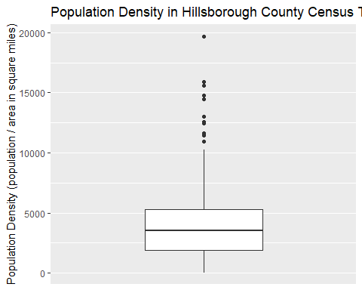

## BIPOC & Poverty

The proportion of the BIPOC members of the population ranged from 3.8% to 97.6%

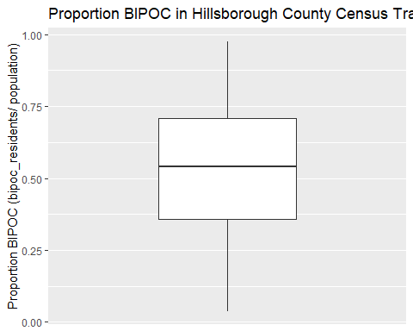

There appears to be a moderate positive correlation (r=0.6310872, p<0.0001) between poverty and proportion of the population within the census tract that is classified as BIPOC.

Pearson's product-moment correlation  
  
data: hbcounty_summary$prop_bipoc and hbcounty_summary$prop_below_150_poverty  
t = 14.621, df = 323, p-value < 2.2e-16  
alternative hypothesis: true correlation is not equal to 0  
95 percent confidence interval:  
 0.5607979 0.6923449  
sample estimates:  
 cor   
0.6310872

